Lab 08: Password Cracking with John the Ripper and Hashcat

Marko Shaffer

Information Security, Franklin University

ISEC 325: Comm/Network Security

Professor Rick Rozzell

7 / 04 / 2021

# **Lab 08: Password Cracking with John the Ripper and Hashcat**

## Follow the instructions from “Lab 08: Password Cracking with John the Ripper and Hashcat.”

* + Note: For all of the screenshots in the following steps, make sure to include the entire browser window to show that you are logged in to Netlab.

## Start with Section 1, “Generating Password Lists for Password Cracking,” and capture screenshots of the following:

### Step 8 output

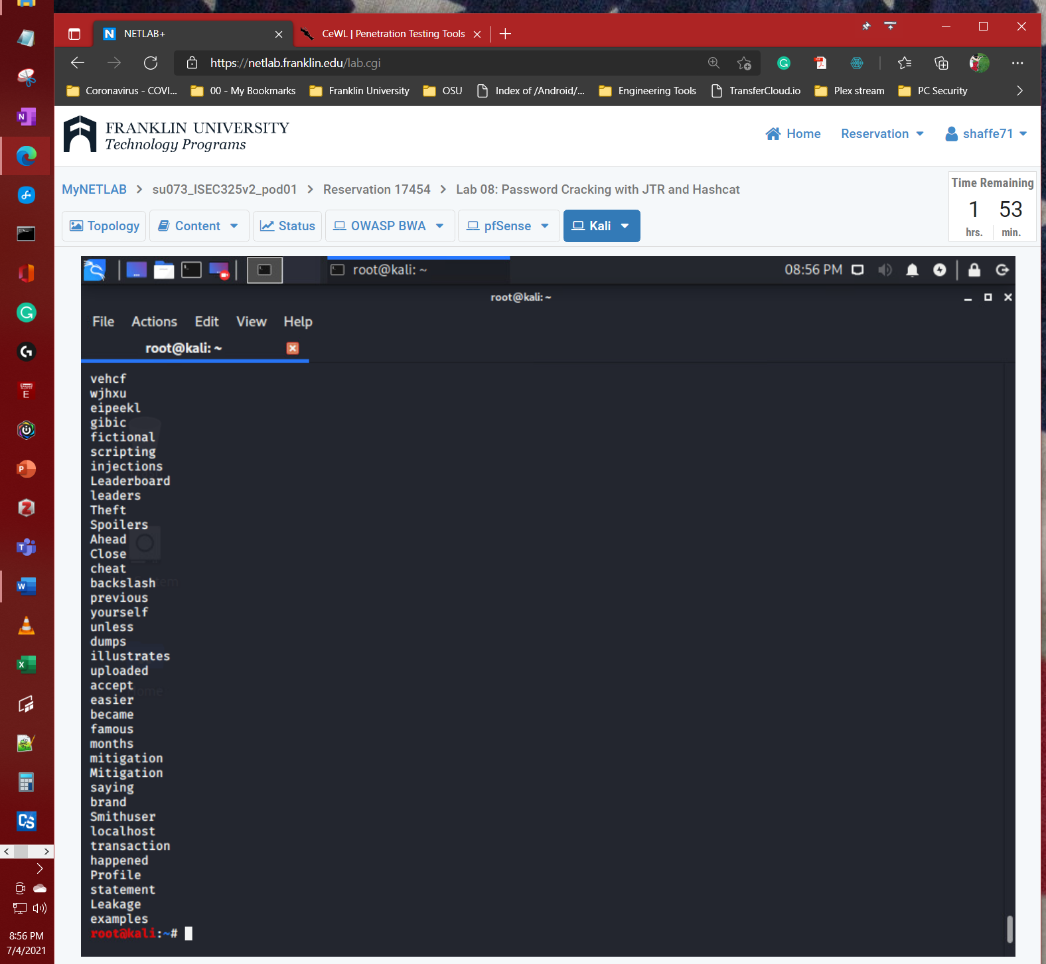

Source: (*NETLAB+*, 2020)

### “tail mylist.txt” after Step 12 is complete

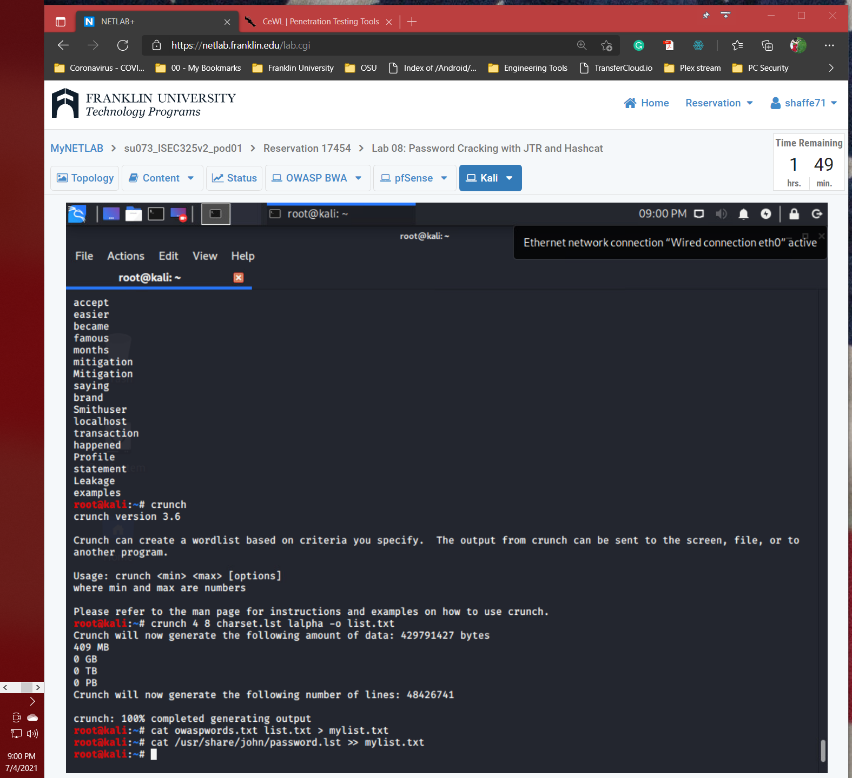

Source: (*NETLAB+*, 2020)

## Continue with Section 2, “Create User Accounts to be Cracked,” and capture a screenshot of the following:

### Step 7 output

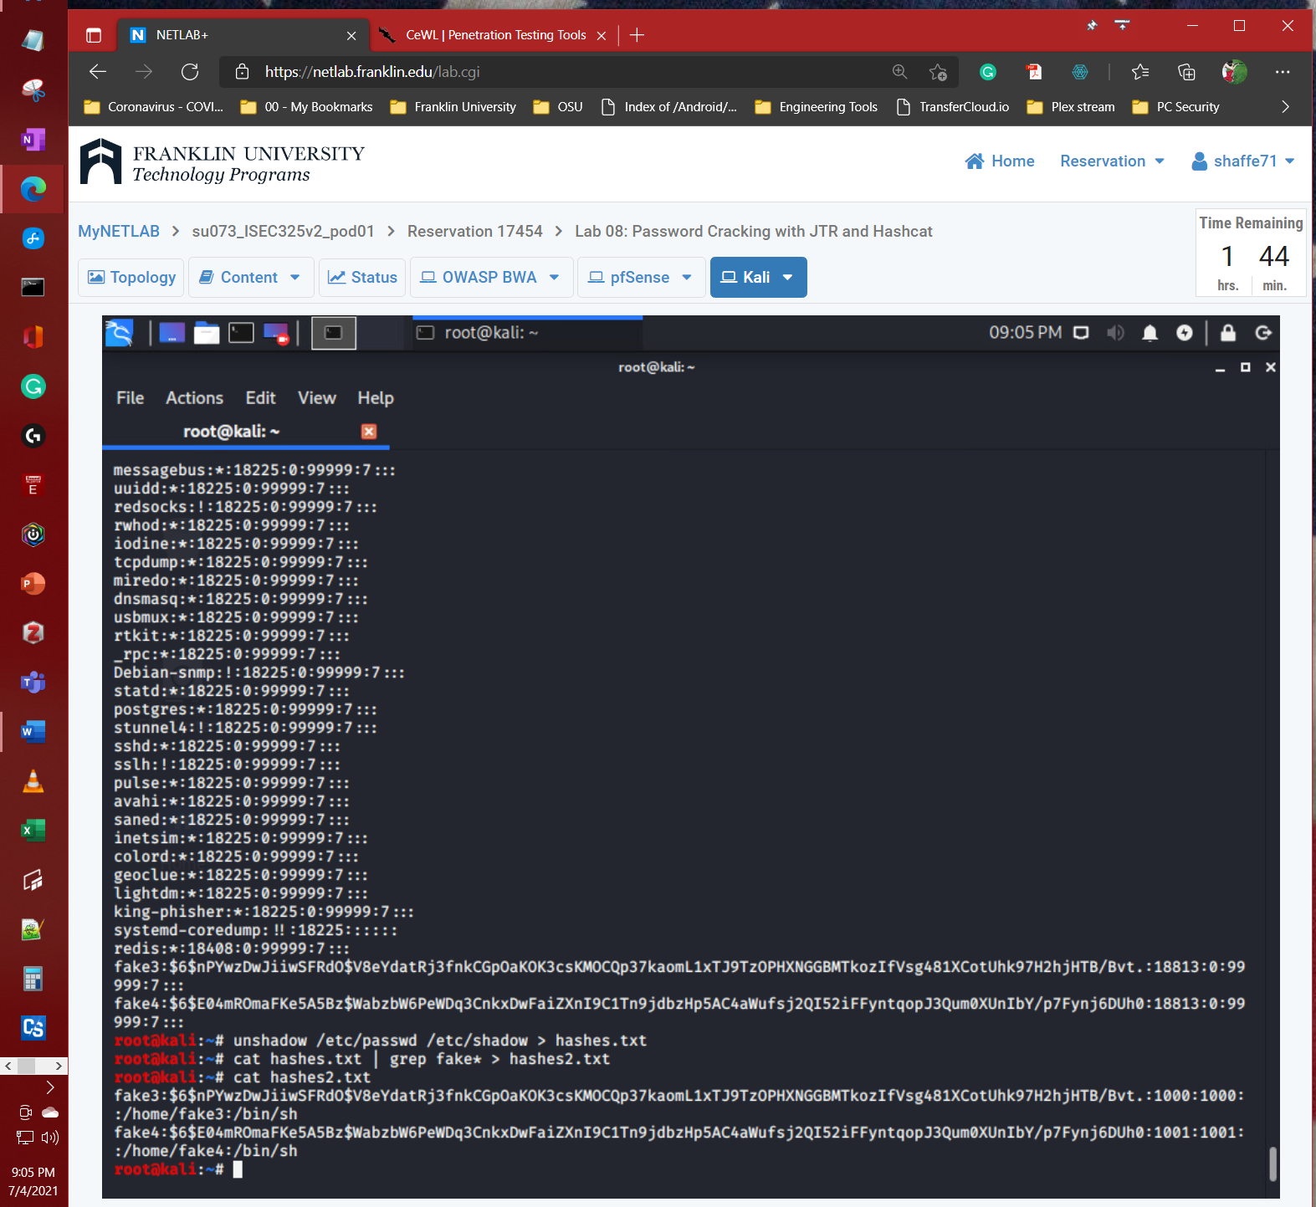

Source: (*NETLAB+*, 2020)

## Continue with Section 3, “Password Cracking Using John the Ripper,” and capture a screenshot of the following:

### Step 3 output

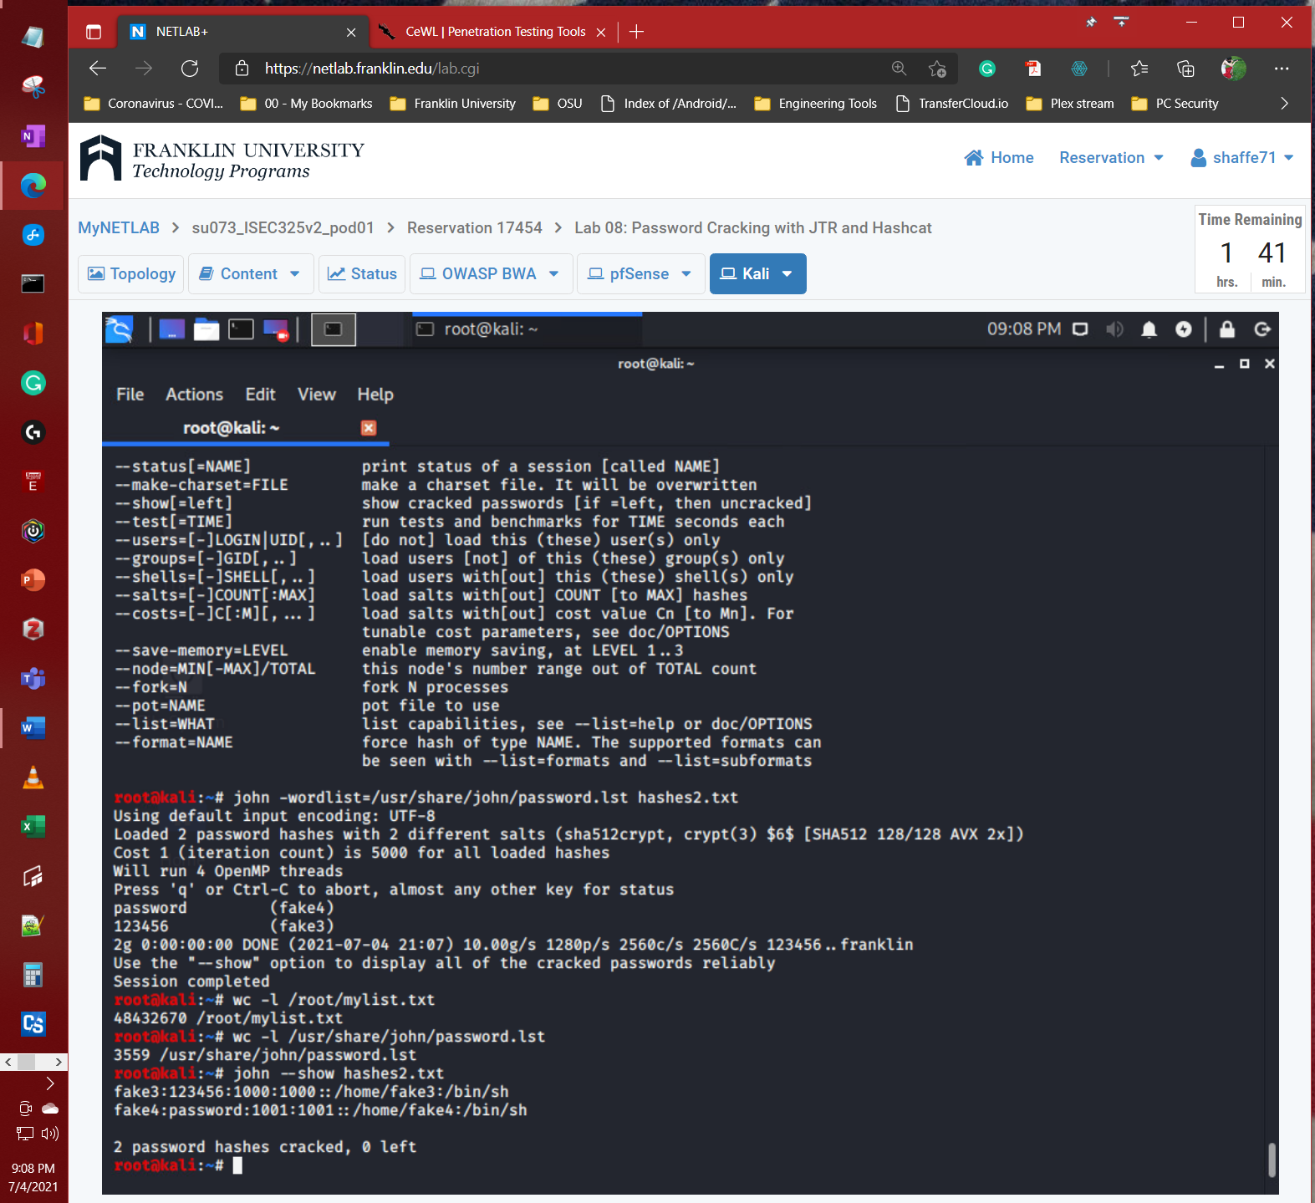

Source: (*NETLAB+*, 2020)

## Continue with Section 4, “Password Cracking Using Hashcat,” and capture a screenshot of the following:

### Step 12 output

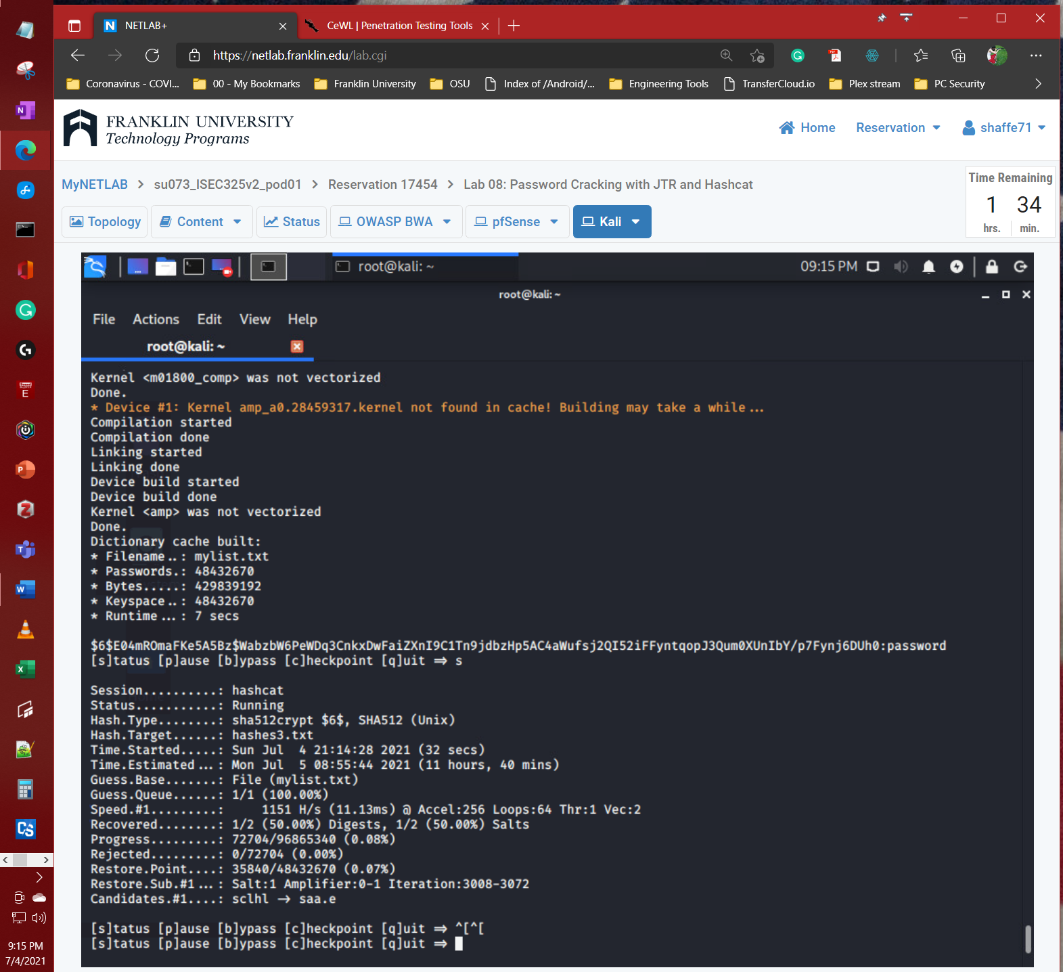

Source: (*NETLAB+*, 2020)

## Summary and Reflection: In a few paragraphs, reflect on what you learned through this lab assignment. Was there anything surprising or unexpected? Was there anything worth investigating further?

I have seen John the Ripper and Hashcat used before on Hak5 and Def Com videos, but have never need to use it my self except for the built in verson of John the Ripper in Cain & Able. I did not know you could create custom word list tables in through the use of cewl based inside of Kali. After using the previously mention packages it has spark my intrest and therefore I will be looking deeper into these packages in the future.

# **References**

*NETLAB+*. (2020). NDG Ethical Hacking v2 (Series-1). https://netlab.franklin.edu/my-netlab-s.cgi